Good Samaritan Medical & Dental Ministry 2014

Dear Good Samaritan Applicant,

Thank you for your interest in our missions to Vietnam. We are honored that you are considering joining our Mission 2014 team by completing this application. This application process is meant for you to learn more about us, what we believe in and what we do, and for us to find out more about you—your goals, objectives and motivation. At the end of this process, we should know enough about each other to make a mutual commitment to grow and serve the poor people in Vietnam.

The Good Samaritan Medical & Dental Ministry (GSMDM) is a nonprofit, non-denominational Christian organization that is responding to God’s call to bring healing to the people of Vietnam. The Ministry started in 1999 and has steadily grown, involving hundreds of volunteers and thousands of supporters.

The Good Samaritan Medical and Dental Ministry is founded on Christian faith and values. As Christians, we believe:

- The unique divine inspiration, entire trustworthiness and authority of the Bible.
- The deity of our Lord Jesus Christ.
- The necessity and efficacy of the substitution and death of Jesus Christ for the redemption of the World, and the historic fact of his bodily resurrection.
- The presence and power of the Holy Spirit in the work of regeneration.
- The expectation of the personal return of our Lord Jesus Christ.
In obedience to God, we share our love through healing tens of thousands of people and changing countless lives. We do not require our members to be of Christian faith, but welcome and respect people of all faith. However, our missions are extremely difficult and demanding; as such we depend on God and draw our strength from Him to accomplish this mission. We do this through worship and devotions every time we gather.

Each year we have two missions:

- The Spring Mission is an educational mission composed mainly of Emergency Medicine physicians, residents, and critical care specialists. The physicians will teach Emergency Medicine through didactic lectures and hands-on experience in various skill labs. This is a perfect opportunity for college, medical and nursing students who cannot afford the time commitment of the summer mission to participate. As a student volunteer, you will: 1) assist the physicians in preparing the equipment and supplies before the mission, 2) help translate during the skill lab sessions while simultaneously learn more about healthcare. You can find out more information on the Spring Emergency Medicine Mission on our website at http://gsmdm.org/em/index.htm or email Dr. Vien Doan at drdoan@gsmdm.org.

- The Summer Mission is a direct patient care mission which provides medical, surgical, dental, pharmaceutical and optometric care to thousands of patients in rural Vietnam. This mission places extreme demands on each of the volunteers for over seven months. More information on this mission can be found on our Summer Mission website at http://gsmdm.org.

You may apply to one or both of these missions. If you are applying to both, please indicate your first choice. If you are applying only to the Spring Mission 2014, the deadline is still December 31, 2013. However, applications are reviewed and interviews are conducted on a first come first serve basis with a rolling admission. Only a small number of positions are available so please send in your applications as soon as possible.

The following information applies to the Summer Mission 2014 only:

Once an applicant is accepted to Mission 2014, GSMDM leaders will train and prepare the new (and sometimes returning) members in every way necessary. This includes: spiritual, mental (learning new skills), clinical, social (team building) and physical training. The discipleship-style preparation for this mission is engaging and often overwhelming, but has proven to be the most rewarding opportunity our members have participated in. Our hopes and prayers for volunteers of this mission are that God will take them to a greater level of commitment to Him, His Kingdom, and His service.

To the people in Vietnam, this is a sophisticated medical mission. There are very few like it. We are looking for a wide variety of skilled helpers along with physicians, surgeons, dentists, pharmacists, nurses and allied healthcare professionals. No medical experience is necessary. You will be trained in detail on how you can be of help to the team and patients. However, please list all your talents and gifts on the application so that we may get to know you better and place you in the appropriate group/team.

In 2004, our ministry created a “Home Team” to assist the mission in its preparation. Applicants who are not accepted for Mission 2014 team and are still interested in helping with any or all phases of the preparation process, are encouraged to join the Home Team. Members of the Home Team will receive special considerations for our future “Field Team” (the team that goes to Vietnam). You are welcomed to apply to either team.

The MANDATORY (meaning if you cannot make it, please consider applying for Spring Mission 2014 or Summer Mission 2015) training dates for Summer Mission 2014 are as follows:

- Friday, January 3 at 5 PM through Sunday, January 5 at 1 PM. This is our general training in Riverside, CA.
- Friday, April 25 at 5 PM through Sunday, April 27 at 1 PM. This is a hands-on FREE CLINIC for the local community in Southern California
- For those who will be flying into Southern California, please choose Ontario (ONT) as your designated airport. This is the closest and easiest airport to coordinate pick-ups.
- Other training and preparation dates are scheduled as well. Members (generally out of state) who live too far away to attend these functions will be notified electronically of the information discussed at these meetings and are held accountable for this information. Fundraising in Southern AND Northern California—which mainly consists of visiting local churches—begin January 18, 2014 and will be held almost every Sunday thereafter until we leave for Vietnam in July (please see the Calendar of Events below). Therefore, members in California must understand that they will be spending many of their Sundays at mission events. You will find, however, these gatherings worthwhile as you grow together with the team and help raise the funds needed to complete the mission.

The success of a mission of this magnitude relies heavily upon the cooperation of all members. This includes submitting to the GSMDM rules and regulations. Operating in a foreign country requires that we honor and obey the country’s laws, customs and traditions. Therefore, we are looking for applicants who are willing to be compliant to a set of rules noted below. These rules may seem strict, but they have been created from years of experience. They are in place to help keep the whole team safe, ensure that we are a better witness for God, and enable us to continue serving the people of Vietnam through the trust that we have built.

Applications must be submitted by November 10, 2013 at 11:59 PM PST. Applications are reviewed on a first come first serve basis with a rolling admission. After reviewing your application, you will be contacted for a personal or Skype interview depending on your location. Please be ready to voice any questions, comments, or concerns during this interview session. Final acceptance notifications will be made on December 1, 2013 by way of a phone call and/or an email.

Thank you again for your interest in the Good Samaritan Medical & Dental Ministry. We look forward to hearing from you.

You are about to make a very important decision. May God bless and guide you.

Mission Committee

GSMDM 2014
Mission Requirements

During Training in the U.S.

- I have read the cover letter to the application, Mission Requirements, and I agree to be faithful to them.

- I understand that I must be over 18 to participate in this mission. However, if I live at home with my parents and/or legal guardians, I must have their permission to participate and will show them the requirements I am committing myself to.

- I will attend our first training weekend on January 3-5, 2014 in Riverside, CA, where I will sign this document.

  - I understand that I am required to be present at the retreat location by 5:00PM on Friday, January 3rd and expected to stay through Sunday, January 5th at 1:00PM.

- I will attend the Training Clinic Retreat on April 25-27, 2014, in Riverside, CA.

  - I understand that I am required to be present at the retreat location by 5:00PM on Friday, April 25th and expected to stay through Sunday, April 27th at 1:00PM.

- I will attend the Mandatory Packing Preparation Day on July 5, 2014 if I live between Ventura and San Diego, California.

- I will attend our Departure Preparation Days starting July 16, 2014 at 8:00AM in Riverside, CA.

- I will keep in touch with team members and leaders, and be responsive to all requests in a timely manner by way of telephone, email, and the team’s online message forum. I understand that the team’s online message forum is the official mode of communication for the team.

- I will attend all other events that are in my region of the country as published on the schedule. From time to time, there may be changes to the schedule. As long as I am informed at least 2 weeks in advance, I will attend the meeting. If I must miss a meeting, I will obtain permission from the Mission Committee by email, phone, or through the team’s online message forum at least one week in advance. Last minute emergencies must be communicated by phone. We understand that emergencies do happen and made provisions for 2 absences. After two absences, I will have the option of either continuing with the mission by paying the professional fee ($900) or resigning.

- I will be responsible for all belongings, items, equipment and assignments entrusted to me. I will set the safety of all mission equipment at a high priority.

- I will treat all team members with love and respect. I will follow the guidance from the mission leaders and my group leader ("Exercise your freedom by serving God, not by breaking the rules. Treat everyone you meet with dignity. Love your spiritual family. Revere God. Respect the government." I Peter 2:16-17). If there is any disagreement, I will discuss the problem with the involved parties. If unresolved, I will bring the issue to: my Clinical Leader, the Committee members, and finally to the Team Chaplain in that order.

- I will make an honest effort to help spread the news about the mission, and raise funds for our team and myself by talking to my pastor, friends and family. I will share our literature, our video and explain our Vietnam Ministry.
- Due to the variable nature of planning for an international mission, I will pay mission expenses and travel fees that may total up to $1800.

- I will comply with instructions given to me by leaders within the team. I understand that if I do not follow through with my responsibilities, I may unknowingly endanger myself, other team members, our patients, and/or the mission itself. If I cannot handle a certain task, I must hand the responsibility to someone who can and will. I understand that not all orders and information can be fully explained to me immediately, especially in high-pressure situations, but I will carry out the assigned tasks all the same (unless I feel a true moral obligation to question it).

- I will complete a medical history and a physical exam, and provide proof of vaccinations for Hepatitis A, B, Tetanus, and Tuberculosis skin test by the due dates mentioned in the Calendar of Events.

RULES Once the Mission Begins

*A note to our professional members: please review the following as they are set to protect everyone who will be with us in Vietnam. It is important for everyone to be kept accountable for safety sake. Thank you!

THE MISSION BEGINS WHEN MEMBERS ARRIVE AT OUR PREPARATION AREA IN RIVERSIDE (THE MISSION DIRECTOR’S HOME) TWO DAYS BEFORE OUR DEPARTURE FOR VIETNAM.
- I will obey all the laws of the government of Vietnam. If I don’t know or have questions, I will ask the Mission Director.
- I will conduct myself in a way that enables the team to complete its tasks and assignments in a safe, timely and efficient manner. This includes, but is not limited to the following:
  - I must be on time for all gatherings, assignments, and tasks knowing that if I am late more than 10 minutes and the team must depart for clinics, 2 of my teammates will have to stay behind for my safety.
  - From the time the team departs for the clinic until the team gets back, I am not to leave the work area until the end of the work day is officially announced.
  - I will adhere to the MIDNIGHT curfew.
- I will, always, conduct myself in a way that gives honor to the name of Jesus. This includes, but is not limited to the following: I will not smoke, drink alcoholic beverages, use illicit drugs, or go to questionable establishments such as massage parlors, bars, karaoke establishments or clubs during the mission.
- When going away from the premises where we are staying, all members are required to travel in a group of 3 because of safety reasons.
- Personal grooming and dress should be appropriate and not offensive to the Vietnamese culture. This includes and is not limited to: wearing tube tops, short shorts, etc. Any tattoos that you may have need to be covered. Refer to Appendix A and/or a Committee Member if you have any questions.
- NO SWIMMING in the in river, lake, or ocean. No wading in water if you don’t know how to swim.

GUIDELINES: The following are guidelines designed for each member’s safety and enable the team to complete our mission.

  - Be responsible for your own passport/visa, paperwork, and personal belongings. You should have a copy of my paperwork with you (at all times), a copy in another secure location (luggage or room), and your group leader must have a copy.

  - Should not ride on mopeds.

  - Should not eat anything raw including vegetables or drink tap water/ice for my safety.

  - Should avoid all animals.

The reward for following these rules is the satisfaction of knowing that we are a diverse group under Christian discipline that serves Vietnam and honors the Lord.

The penalties for breaking any of the above rules are: (1) The member will be given a warning by the mission leaders and a witness. A public announcement of the incident will be made so that others can learn from it, but no identities will be disclosed. (2) If that same member again violates a rule, he/she will be immediately dismissed from the team. That member will be responsible for his/her own transportation and lodging out of the mission work area. (3) After that, ANY member that breaks any rule will be dismissed as well. (4) Any actions deemed unsafe for patients, team members and self may result in immediate dismissal by the medical director in charge at the time the incidence occurred.

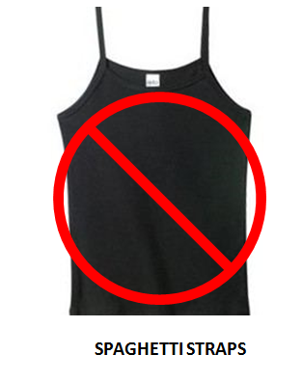
Appendix A: NOT OK to wear while in Vietnam
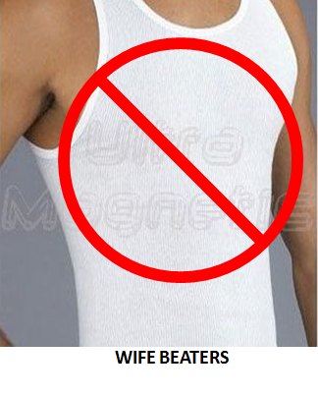
Appendix A: OK to wear while in Vietnam

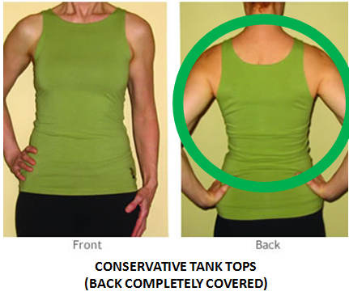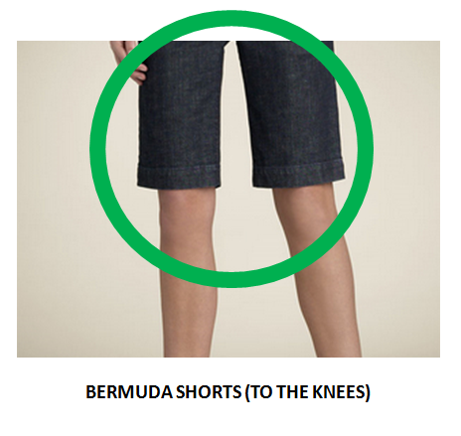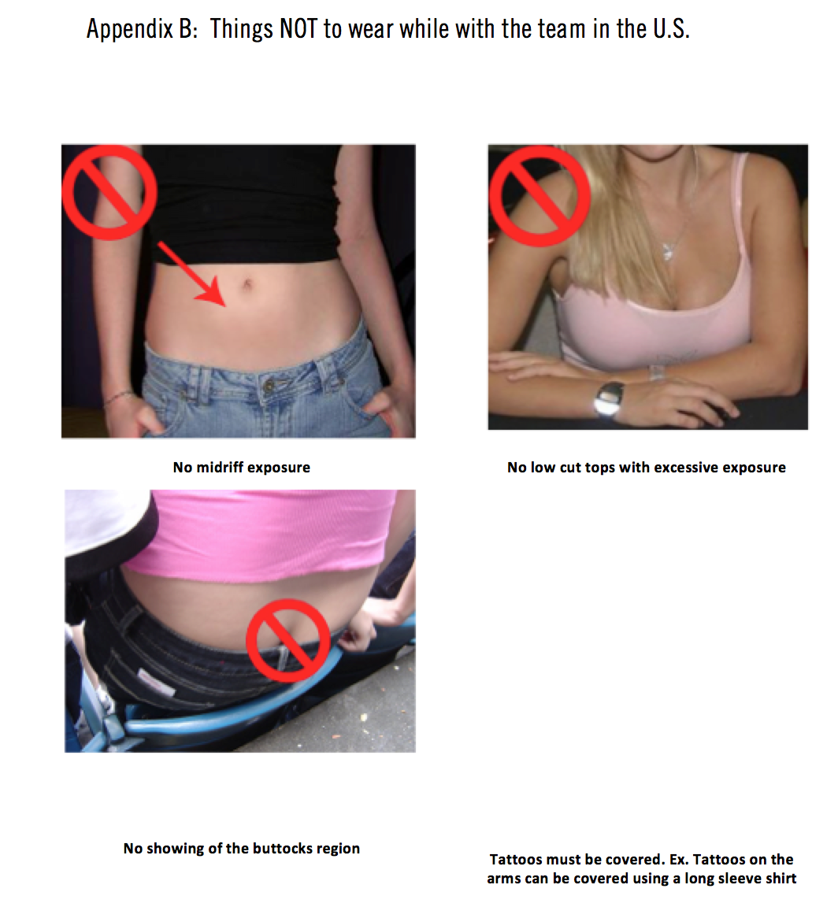

GSMDM Summer Mission 2014

CALENDAR OF EVENTS

- November 10: Deadline for Applications (at 11:59p.m.)
- December 1: Final notification of application status
- January 3-5: Training Retreat, Riverside, CA (mandatory for ALL members)
  - Hepatitis A and B vaccines series.
  - Tetanus vaccines needed for those who have not had it in 10 years.
  - Tuberculosis skin test must be within 12 months to the date of travel.
  - Hepatitis A, B, Tetanus and TB skin tests must be current at the time of acceptance. If you cannot show documentation that you had received them, we will help provide those shots for you at a cost. The entire cost for the missing shots must be paid at the January Retreat, no exception.
    - TB skin test: $4
    - Hepatitis A: $67 each and 2 are required
    - Hepatitis B: $55 each and 3 are required
    - Tetanus: $22
  - Those without a passport must have applied for one by this date.
- January 18: Second Training Day (S. Cal) *Second dose of Hepatitis B Vaccine must be completed
5. January 25: Fundraising meeting – TBA
6. February 9: Fundraising meeting – TBA
- February 23: Fundraising meeting – TBA
- March 9: Fundraising meeting – TBA
9. March 16: Fundraising meeting – TBA
*Money is due for airplane tickets.
- March 23: Fundraising meeting – TBA
- March 30: Fundraising meeting – TBA
- April 6: Fundraising meeting – TBA
- April 13: Fundraising meeting – TBA
- April 25 – April 27: Training Clinic Retreat (Mandatory For ALL Members)
- May 4: Fundraising meeting – TBA
- May 11: Mother’s Day (No meeting)
- May 18: Fundraising meeting – TBA
- May 25: Memorial Day Weekend (No Meeting)
- June 1: Fundraising meeting – TBA
- June 8: Fundraising meeting – TBA
- June 15: Father’s Day (No Meeting)
*Hepatitis A & B MUST be completed by this date
- June 22: Fundraising meeting – TBA
23. June 27: Mandatory Packing Preparation (S. Cal)
- July 16, 17: Departure Preparation Days (Mandatory for ALL members)
- July 18: Depart for Vietnam
- August 2: Mission Ends after team dinner

Northern California Fundraising Meetings
- January 19: Fundraising meeting – TBA
- February 9: Fundraising meeting – TBA

- February 23: Fundraising meeting – TBA
- March 9: Fundraising meeting – TBA
- March 23: Fundraising meeting – TBA
- April 13: Fundraising meeting – TBA
- May 18: Fundraising meeting – TBA
- May 25 Fundraising meeting – TBA
- June 8: Fundraising meeting – TBA
- June 22: Fundraising meeting – TBA
- June 29: Fundraising meeting – TBA

NOTE: These are projected dates for fundraising. Aside from the mandatory events, the calendar is provided so you may better plan for these prospective fundraising events.

Good Samaritan Medical Ministry
Mission 2014 Application
DEADLINE November 10th, 2013 at 11:59 PM

Today’s Date:
I am applying for:
☐ Home Team
☐ Field Team: Spring 2014
☐ Field Team: Summer 2014

Full Name as it appears on your passport: Surname is Last name and Given name is first name followed by middle name.
Surname: Given Name:

Name you would like to be called:
Date of Birth: Gender: Male ☐ Female ☐
Address:
City: State: Zip Code:
Cell Phone: Home Phone:
Email Address:
Home Church:
If you are currently living at home with your parents or your parents are still supporting you financially, you must inform them you are applying to this mission. Before you are accepted you must have your parent’s permission to participate. Their decision to allow you to participate on this mission before your interview will in part determine your acceptance.

I have informed my parents of my intention to participate in this mission AND:
☐ My parents have approved of my decision.
☐ My parents have not approved of my decision and we are actively discussing it. I will have a decision for the interviewer on the date of my interview.
☐ I am independent.

Mission Objectives:
- To be instrumental in sharing God’s love and healing.
- To build bridges between the church and communities.
- To model compassionate care.
- To develop servant leaders.

- Please share your reasons for wanting to participate in Mission 2014.

- If you are applying to participate with the “Field Team” in Vietnam and are not accepted, are you interested in being part of the “Home Team” and assisting in the preparation?

- Have you ever been involved with any previous missionary work? If so, in what capacity and how has it affected you?

- How would you like to contribute to the mission? Please list interests, skills, talents, and experience such as leadership, music, skits, children’s programs, technical, medical or anything unique about you that you would like to bring to the team.
- What is your current occupation? If you are currently in school, what is your current field of study?

- What languages do you know? Explain your level of fluency in reading, writing, speaking, and interpreting (including English).

- Have you ever been to Vietnam? When? How familiar are you with the country, the land, the language, the people, and the culture?

- Does Vietnam have a special place or meaning in your life? Do you have any vision of personal involvement for Vietnam in the future – family, business, charity, missionary work, etc…
- How will you assist Good Samaritan Medical & Dental Ministry in obtaining prayer and financial support? Will your home church and/or youth group support you on this mission? If so, how?
- If asked to be a part of the mission, how do you plan to prepare yourself spiritually and emotionally to respond to God’s call (e.g., prayer or other practices)?

- Tell us about your ability and willingness to adapt to all the changes that you will encounter (e.g.: weather and environment, living conditions, ethnic food, work environment, etc).
- How are you as a team player, both as a leader and as a follower? Which do you consider yourself to be more of?
- What is the importance of rules and regulations? Now that you have carefully reviewed the Rules and Regulations document, how do you plan to stay committed to these standards?
- This mission involves your time in the U.S. in addition to our days in Vietnam- fund-raising, training, and meetings. How many hours each week are you able to contribute to the mission?

- As stated in the Rules and Regulations, the majority of fund-raising events are held in churches. How comfortable are you attending and participating in these events?

- Tell us about your experience in the medical/dental fields? (Prior experience is not required.)
- Is there anything else you would like us to know about you (e.g. Hobbies, what you do in your free time)?
- This is a Christian mission. Where do you see your relationship with God? Are you happy where you are? How do you hope to be different in the next five years?

- Please provide a professional reference; email or phone number of a person that can tell us more about you, your work ethic, and your responsibility level. This can be a pastor, teacher, supervisor, co-worker, committee member, colleague, etc.

- The introduction letter states: “We do not require members to be of ________ ”.

- On the calendar of events it states that: If I can’t show proof that I had Tetanus, Hepatitis A, B and TB skin tests, the Ministry will administer those vaccines to me at the total cost of _______.

- The Mission Requirements while in the US states: I will keep in touch with team members and leaders, and be responsive to all requests in a _____________________.

- Once the Mission begins in Vietnam the Rules states: I will conduct myself in a way that enables the team to complete its tasks and assignments in ________________.

Thank you so much for taking the time to complete this lengthy application. We look forward to contacting you soon.

Submission Instructions:

Change the name of this application to your name followed by 2014 Application. Example: “John Doe 2014 Application”.

Please email your application to apply14@gsmdm.org. The Subject Line should have your name followed by 2014 Application, example “John Doe 2014 Application”.

Once you have submitted your application, you can check to see if it has been received by logging into our website at http://gsmdm.org/summer/received_app.htm. Please allow 24-48 hours to have your name updated.

If you have questions completing this application, please contact Luke Doan, Mission Committee Member, at luke@gsmdm.org.

Please be sure to check your email regularly after November 10th, 2013, to see if you have received an email from GSMDM. Also be sure to check your spam folder, often times GSMDM mail can get sent there by aggressive spam filter.

